CougaarUnit
User’s Guide


CougaarUnit 1
Introduction 3
Overview 4
Blackboard State Change Concept 4
Installing CougaarUnit 5
Approaches to Testing 8
Prescriptive Testing 8
Postscriptive Testing 8
Creating a Test Suite 10
Examples 12
Object Stream Editor 13
Instrumenting An Agent 13
Analyzing Object Stream Data 14

Introduction

CougaarUnit is a framework for performing isolated testing on Cougaar component plugins. It’s purpose is to provide Cougaar developers with a mechanism of validating a plugin’s performance apart from it’s integration into a Cougaar society. In this respect, it is analogous to the JUnit test framework currently used for testing Java classes. JUnit provides method level testing of Java classes by allowing the developer to develop test cases which call specific methods and assert expected return values. In other words, it allows for the testing of a method’s exposed interface (method signature). CougaarUnit does a similar thing, but instead of the interface being a method signature, it is defined as a series of Cougaar blackboard publication events. Plugins are tested by evalutating their respondes to blackboard publication events against an expected series of publication events. Thus, to the degree that a plugin’s interface can be defined by it’s blackboard activity, this plugin can be tested within the CougaarUnit framework.

Overview

Blackboard State Change Concept
The overall approach in unit testing cougaar plugins is to track the changes to the blackboard state rather than the actual state of the blackboard itself at any given time. The concept is that we want to validate a plugins condition by defining it’s behavior in terms of it’s blackboard interactions. This is certainly not the only way of evaluating the validity of a plugin, nor should it be used in the place of traditional unit testing tools; however, this technique can be combined with existing testing techniques to provide an additional level of verification as to the appropriateness of a plugin. In it’s simplest terms, the test framework enables a developer to simulate blackboard activity by allowing the assertion of object activity onto the blackboard and then capture the plugins response in terms of it’s blackboard activity. The response of a plugin to a series of blackboard assertions comprises what we call the Blackboard Delta State, which is simply the changes which have occurred in the blackboard as a result of the plugin’s response to the test assertions. The test framework also allows the developer to define “expected” blackboard delta states so that the framework can then evaluate the expected states against the actual states.

Installing CougaarUnit
Two files are required for CougaarUnit to function properly: the CougaarUnit.jar file and the CougaarUnitApp file. The CougaarUnit.jar file must be placed in the COUGAAR_INSTALL_PATH/lib directory. The CougaarUnitApp comes in three flavors: a console version (CougaarUnitApp.exe), a windows version (CougaarUnitAppW.exe) and a linux executable version (CougaarUnitAppLinux). This file can be run from anywhere.
Architecture
Its basic architecture is very similar to the JUnit Framework used for unit testing java classes. From the user’s perspective (the user being the developer wanting to test his/her plug in), all that is needed is to create a class that subclasses the PluginTestCase class. This super class provides all the necessary framework for running the unit test of a cougar plugin. In order for the Unit test to work, the tester must implement three methods: validateSubscriptions , validateExecution, and getPluginClass.

- validateSubscriptions: This method is provided to allow the tester to test the validity of the various unary predicates within source plug in.
- validateExecution: This method is there to allow the tester to test the validity of the execution statement within the source plug in.
- getPluginClass: This method is used to supply the framework within full path specification of the source plugin.

Two optional methods may also be implemented when necessary:
- getPluginParameters: Used to specify any parameters that are required by the source plugin.
- getAgentId: Used to specify the name of the agent that the plugins (both source and test plugins) will be loaded into. By default the agent name is “TestAgent”.

To support and testing of the source plug in, The following series of methods are implemented within the PluginTestCase Class . These methods are as follows:

public void subscriptionAssert(Object obj, boolean expectedResult):
This method is used within the context of the validateSubscriptions method. The tester constructs subscriptionAssert calls in such a way as to validate the functionality of the unary predicates within the source plug in. Essentially, the tester simply calls this method and passes an object and an expectedResult value which indicates whether they expect this call to pass or fail. This allows the tester to test for both positive and negative results. The framework will call each of the unary predicates for the source plugin to see if it can get a positive result. If the object is accepted by one of the unary predicates, the result is considered to be positive and it is then evaluated against the expected result. If the actual result and the expected result match, then the test passes. If they do not match however, then the test fails.

public void assertPublishAdd(Object obj, BlackboardState bbs, long waitTime, boolean expectedResult)
This method is used in the context of the validateExecution Method. The tester simply calls assertPublishAdd and passes in an object to be published to the blackboard, a BlackBoardState object that defines the expected state of the blackboard after the object is published, the length of time to wait before testing to see if a blackboard state is achieved, and an expected result. The two key components within this method call are the BlackBoardState object and the waitTime.

- BlackBoardState: This object can be of little confusing. It does not represent the state of the blackboard as a collection of objects that currently exist on blackboard, as would normally be thought. Instead, it represents a series of actions that are performed over time within the blackboard. For example, if the source plugin is written such that when a particular object is published to the blackboard, a series of other objects are then published to the blackboard by the source plugin, then that series of publications would constitute a blackboard state object.
- waitTime: The reason that the waitTime argument is placed within the method is that the series of resulting publications will require a certain length time to occur. Also it is important to note that the BlackBoardState object and the waitTime are not required to be specified. In the event that they’re not, the framework assumes that there is no expected state as the result of the test publication. This is necessary since it is very likely that many plugins will require a series of test publications to occur before any result is expected. So it is conceivable that within the test method the user may call assertPublishAdd many times before actually passing in a BlackBoardState object.

public void assertPublishChange(Object obj, bbs BlackboardState bbs, long waitTime, boolean expectedResult)
This method works very similarly to the assertPublishAdd method except that it publishes a change to an existing object rather than a new object.

public void assertPublishRemove(Object obj, bbs BlackboardState bbs, long waitTime, boolean expectedResult)
This method works very similarly to the assertPublishAdd method except that it publishes a removal of an existing object rather than an addition of a new object.

Approaches to Testing
There are essentially two different approaches that can be taken to developing CougaarUnit tests. I label these two approaches as the prescriptive approach and the postscriptive approach.

Prescriptive Testing
In this approach the developer would write the CougaarUnit test before writing the actual plugin. This approach requires that the Blackboard publication activity can be defined (at least in part) before the plugin is written. Using this technique, the tests can become a validation mechanism to ensure that the plugin to be written conforms to an established pattern of behavior.

Postscriptive Testing
This would be the approach used for testing existing plugins. This approach assumes that a correctly operating plugin already exists and the CougaarUnit tests are written to recreate some portion of the Blackboard behavior of the plugin. The object stream analysis tools can come in useful here in order to identify cause-and-effect behavior between plugins so as to construct tests which recreate this behavior. Once the tests are constructed, they can serve the same purpose as in the prescriptive testing approach in that subsequent changes to the source plugin can validated using this base of CougaarUnit tests.
Creating a Test Case
The first step in creating a test case is to create a subclass of the PluginTestCase class. In order to minimally implement this subclass, the getPluginClass(), validateSubscriptions(), and validateExecution() methods must be implemented. Additionally, the getAgentId(), getDescription(), and getPluginParamters() can be implemented to provide additional functionality.
Creating a Test Suite
One of the difficulties in developing unit tests for cougaar plugins is the issue of test setup. In order to prepare a plugin to be tested, it may be necessary to perform many blackboard operations. If another test is then to be run, the blackboard should ideally be returned to it’s initial state. The problem with this is that the removal of objects from the blackboard may trigger additional activity within the plugin being tested which may invalidate any further tests. This is not the case for testing subscriptions since the framework never actually touches the blackboard during the subscription test phase. However, during the execution test phase the blackboard is impacted. Hence, to perform multiple execution tests against the same plugin it is necessary to develop multiple plugin test cases that can be run against that plugin. In order to make the logical grouping of such test cases easier, the TestSuite concept has been employed. The TestSuite object allows the developer to specify a series of individual PluginTestCase classes that comprise the test suite. When a test suite is executed by the infrastructure it searches out the constituent test cases within the suite and then executes them sequentially.
Running a Test Case
One of the main goals of the CougaarUnit development effort is to allow unit tests to be run unattended on the development server in order to achieve a higher degree of continual testing. However, during the development of a PluginTestCase there is also a requirement to provide the developer with feedback as to the performance of the test case. This is especially true with Cougaar since the test case setup can get fairly complex. To facilitiate the test case development effort, a UI is provided with the CougaarUnit framework. The UI provides feedback as to the success or failure of specific tests as well as information as to why particular tests failed. In order for this tool to work properly, Cougaar must be installed in the local machine and must be configured properly (i.e., the COUGAAR_INSTALL_PATH must be set).
Figure 1 shows the main display of the CougaarUnit user interface.

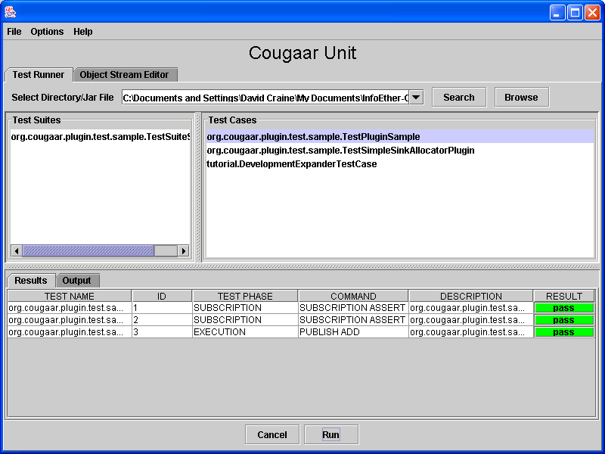
Figure 1
Examples
public class SamplePlugin extends ComponentPlugin {
private IncrementalSubscription testIS;

UnaryPredicate testUP = new UnaryPredicate() {
public boolean execute (Object o) {
if (o instanceof TestBBMessageObject)
return true;
return false;
}
};;

protected void setupSubscriptions() {
testIS = (IncrementalSubscription)getBlackboardService().subscribe(testUP);
}

protected void execute() {
Collection messages = testIS.getAddedCollection();
if (!messages.isEmpty()) {
for (Iterator iter=messages.iterator(); iter.hasNext(); ) {
System.out.println("added: " + iter.next());
}
getBlackboardService().publishAdd(new TestBBMessageObject2());
}

messages = testIS.getChangedCollection();
if (!messages.isEmpty()) {
for (Iterator iter=messages.iterator(); iter.hasNext(); ) {
System.out.println("changed: " + iter.next());
}
getBlackboardService().publishAdd(new TestBBMessageObject3());
}

messages = testIS.getRemovedCollection();
if (!messages.isEmpty()) {
for (Iterator iter=messages.iterator(); iter.hasNext(); ) {
System.out.println("removed: " + iter.next());
}
getBlackboardService().publishAdd(new TestBBMessageObject4());
}

}
}

public class TestPluginSample extends PluginTestCase {
public void validateSubscriptions() {
subscriptionAssert(new TestBBMessageObject(), true);
subscriptionAssert(new TestBBMessageObject2(), false);
}

public void validateExecution() {
BlackboardDeltaState bbs = new BlackboardDeltaState();
bbs.add(new PublishAction(PublishAction.ADD, new TestBBMessageObject2()));
assertPublishAdd(new TestBBMessageObject(), bbs, 5000, true, false);
}

public String getPluginClass() {
return "org.cougaar.plugin.test.sample.SamplePlugin";
}
}

Object Stream Editor
The object stream editor is a tool built into the CougaarUnit user interface for displaying captured streams of blackboard object events. This section will describe how to instrument an agent to capture this data, and then how to use the object stream editor to analyze the data.

Instrumenting An Agent
To enable the capturing of blackboard events into an object stream, three components need to be installed into an agent’s .ini file or CSMART recipe. These components are:

plugin = org.cougaar.plugin.test.capture.BlackboardCaptureServletComponent

Node.AgentManager.Agent.PluginManager.Binder(BINDER) = org.cougaar.plugin.test.capture.BlackboardCaptureFilter

Node.AgentManager.Agent.DomainManager.Domain = org.cougaar.plugin.test.lp.MessageMonitorDomain(message_monitor)

When these three components are installed for an agent, blackboard events can then be dumped out to a file at any time by browsing to the BlackboardCaptureServletComponent, specifying a file name, and clicking the ‘Capture’ button as shown in Figure 2.

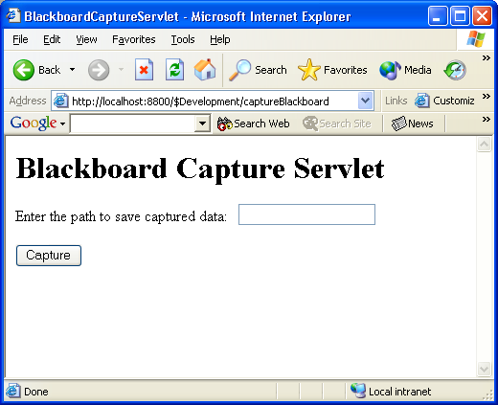
Figure 2

Analyzing Object Stream Data
By selecting the Open Data File item in the file menu, the user can load the contents of the object stream that was captured in the previous step. The data can be displayed in two different views: Time View and Source View. The time view shows the sequence of blackboard events in chronological order with each row representing a separate event and the the columns representing the content of each event. The source view still maintains the sequential ordering of rows, but the columns represent the source of each event (i.e., which plugin or external agent generated the event). The contents of each cell contains a description of each individual event. Figure 3 and Figure 4 below show these two different views.

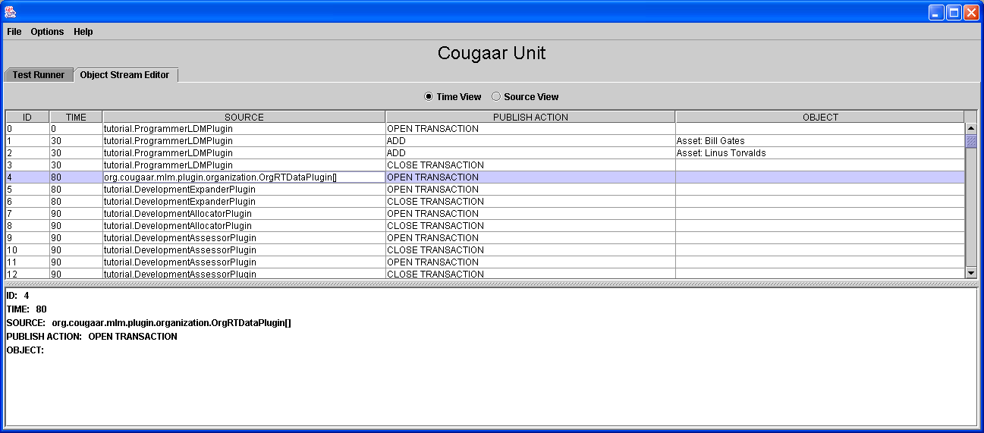
Figure 3 - Time View

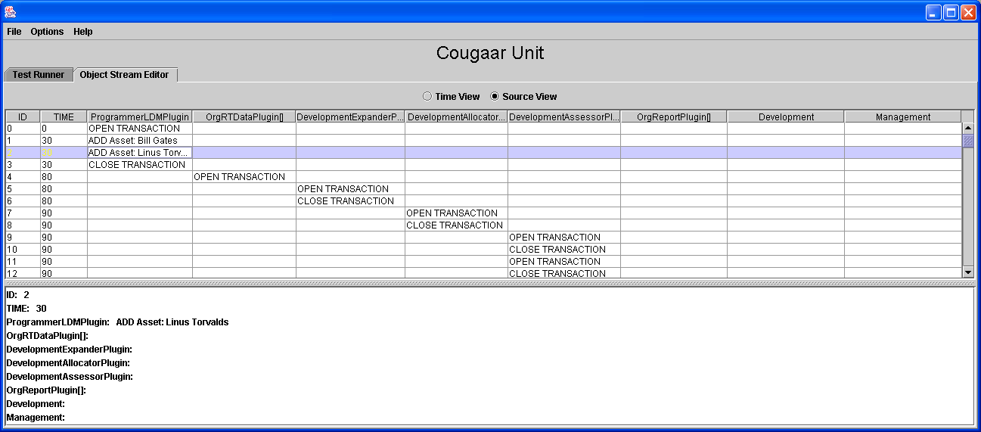
Figure 4 - Source View
The purpose of this tool is to enable a developer to view the current blackboard interactions of plugins in order to better enable them to develop CougaarUnit tests for those plugins.

